6D5N YANGON – BAGAN – MANDALAY – YANGON
DAY 1: YANGON ARRIVAL – CITY SIGHTSEEING ( L/D)
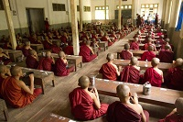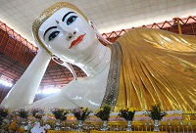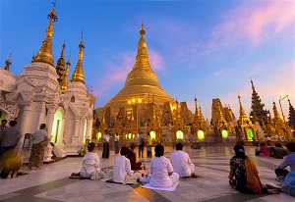
Kalaywa tawya Monastery Chauk Htat Gyi pagoda Shwedagon Pagoda

Arrival Yangon, pick up by guide then drive to Tooth Relic Pagoda and you have a chance to study KALAYWATAWYA MONASTERY, a monastery with high reputation consists of between 500 to 1000 young novices can be seen at the same time while they have their 2nd or the last meal of the day. It is very well-worth seeing.

In the afternoon, the tour will continue to CHAUKHTATGY, a huge reclining Buddha image, extended visit to SHWEDAGON PAGODA, one of the world’s most spectacular religious monuments and the golden dome of Shwedagon Pagoda rises 98meters above its base and is covered with 60 tons of pure gold., will conclude the tour of this picturesque garden city.
Overnight at Hotel in YANGON.

Meal : 1 Lunch + 1 Dinner
Accommodation: Overnight in Yangon.
The distance: Yangon International Airport – Yangon Capital : 15km – 40minutes for transfer.

DAY 2: YANGON – BAGAN SIGHTSEEING ( B/L/D)
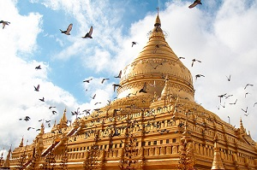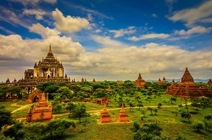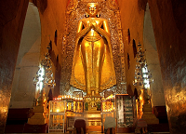
Shwezigon Pagoda Gubyanuk Gyi Ananda Temple

After breakfast, transfer to airport and fly to BAGAN. Starting with the busy local market and continuing with visits to a diverse selection of the most important Pagodas and temples, such as SHWEZIGON POGODA, built by King Anawrahta in the early 11th century, GUBYANUKGYI, a temple with exquisite murals of Jataka scenes, and ANANDA TEMPLE with four huge standing Buddha images and numerous seated figures in niches around the galleried interior. Lunch is followed by a visit of a lacquer craftsmen’s workshop nearby Myinkaba village. Continue sightseeing to MANUHA TEMPLE Manuha Temple, built in Mon Style in 1095, NANBAYA TEMPLE, a unique sandstone monument, said to have been the palace of King Manuha and MyingabaGuByaukgyi Temple, noted for its ancient mural paintings under the protection of UNESCO.
Overnight at hotel in BAGAN.

Meals: 1 Breakfast + 1 Lunch + 1 Dinner
Accommodation: Overnight in Bagan
The distance: Nyaung U Airport – Hotel : 8km – 15 minutes for transfer

DAY 3: BAGAN – MANDALAY – AMARAPURA – CITY SIGHTSEEING ( B/L/D)
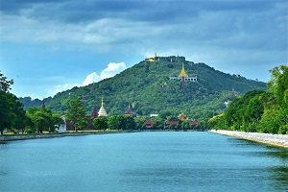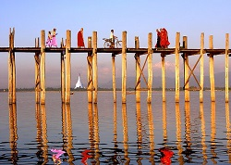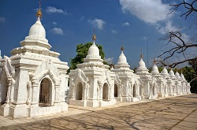
Mandalay Hill U Bein Teak Wood bridge Kuthodaw Pogoda

After breakfast, transfer to airport and fly to Mandalay. Arrival Mandalay, drive to AMARAPURA. Visit about 200 years old U BEIN TEAK WOOD BRIDGE. Then proceed to MAHAGANDARYON MONASTERY where there are more than 1500 Buddhist monks. Then proceed to MAHAMNUNI PAGODA with its spectacular Buddha image covered with thick layers of gold leaves, Gold-leaf beating, SHWE NAN DAWKYAUNG OR GOLDEN PALACE MONASTERY, a superb example of a traditional wooden building and KUTHODAW PAGODA, known as the world's biggest book, consisting of 729 marble slabs engraved with Buddhist scriptures. Among the historical buildings craftsmen’s workshop like Bronze casting, Marble stone carving, Kalaga tapestries, should be seen. Sunset from MANDALAY HILL. Overnight at hotel in MANDALAY.

Meals: 1 Breakfast + 1 Lunch + 1 Dinner
Accomodation: Overnight in Mandalay
The distance: Mandalay city – Mandalay city airport: 35 km – 50 mins for transfer

DAY 4: MANDALAY – MINGUN – SAGAING – MANDALAY ( B/L/D)
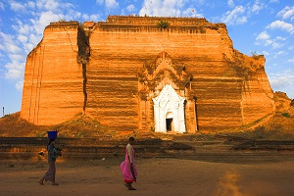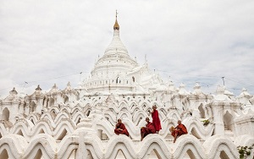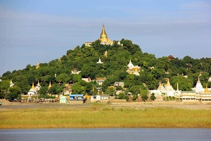
PATHODAWGYI PAYA MYATHEINDAN ZEDI SAGAING HILL

Boat trip on the Ayayyarwaddy River to MINGUN about 11km (1hour) upriver from Mandalay with visits to the the PATHODAWGYI PAYA, built as one of the world’s largest chedis by King Bodaw Paya. MINGUN BELL, weighing 90 tons and being the largest uncracked bell in the world, to MYATHEINDAN ZEDI. Then proceed to Sagaing by driving over 1 kilometer long bridge across the Ayeyarwaddy River to SAGAING HILLS, SOON U PONYA SHIN PAGODA situated on the top of the Sagaing Hill, KAUNGHMUDAW PAGODA and many other local pagodas are of interest. Silver-smiths still fashion intricate and unique jewellery in Sagiang and their workshops are worth visiting to purchase eye-catching necklaces and bracelets are inexpensive prices.
Then drive back to Mandalay. Enjoy the dinner & overnight in Mandalay.

Meals: 1 Breakfast +1 Lunch + 1 Dinner
Accomodation: Overnight in Mandalay
The distance: Hotel in Mandalay – Mingun – Sagaing : 47km – 1hour & 40 minutes for transfer

DAY 5 : MANDALAY - YANGON (B/L/D)
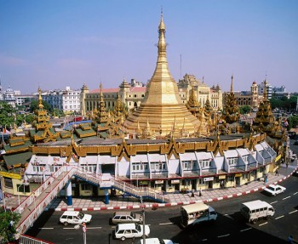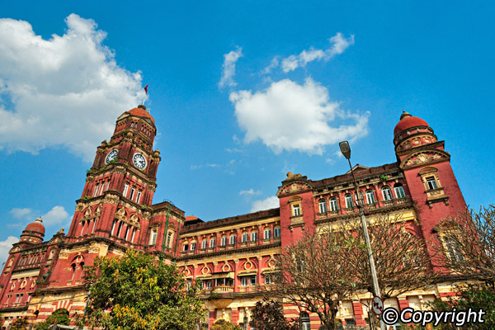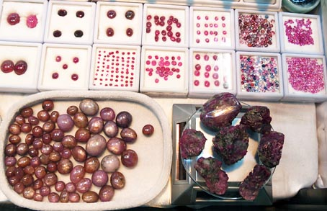
Bogyoke (Scot’ts) Market

After breakfast, transfer to airport and fly back to Yangon.
In the afternoon, enjoy excursion to the city center where SULE PAGODA, City hall, High Court, Immanuel Church & MARHARBANDOOLA PARK with Independent Monument, located to see the bustling life of Yangon and City Hall.You continue the tour to the well-known BOGYOKE MARKET (FORMER SCOTT MARKET), where one can buy many items in one place. This Market was built in British colonial times and has a colonial shape.
Dinner and overnight in Yangon.

Note: Bogyoke or Scott Market is closed every Monday and Public Holidays.

Meals: 1 Breakfast +1 Lunch + 1 Dinner
Accomodation: Overnight in Yangon
The distance: Hotel in Mandalay – Mandalay International Airport : 36km – 46min for transfer

DAY 6 : YANGON DEPARTURE ( B)
Time at leisure to pursue individual interests until your transfer to the airport. Then transfer to airport for your departure.

(If you have time, on the way to airport, we can visit SWETAWMYATZEDI (the pagoda relic replica of the tooth of Buddha) Pagoda, KABARAYE (or World Peace Pagoda), KYAUKTAWGYI PAGODA also known as LawkaChantharArbayarLaba Muni Buddha Image at MinnDhamma Hill, there is an Elephant house where the three white elephants are kept. Extra cost will be applicable.)

Meals: 1 Breakfast
The distance: Yangon Capital – Yangon International Airport : 15km – 40minutes for transfer

The ends of program!

SEQUENCE OF ITINERARY SUBJECT TO LOCAL ARRANGEMENT

PRICE INCLUDE:
- Accommodation – as hotel in the list or similar – based on Twin/Double/Triple sharing
- Tour guide: English speaking guide during the tour.
- Daily ABF and meals as mentioned in the program
- Shows and sightseeing in schedule.
- Transportation by private air-conditioner
- Boat trips mentioned
- 01 bottle ( 500 ml )of drinking water for each pax per day.
- Meals (Burmese Food & Chinese Food) as the tour code ( B: Breakfast, L: lunch, D: Dinner)
- Domestic flights tickets

PRICE EXCLUDE:
- International flight ticket & airport tax (if have)
- Personal expenses: Tel, Fax, Mini Bar, Laundry,etc.
- Personal travel insurance
- Compulsory Tip for local guide and driver (USD/PAX/DAY)

Group Size | Tips in USD
2 – 4pax | 6
5-7pax | 5
8 - up | 3

- Surcharge with other languages guide.
- Surcharge at hotel case by case
  - Chinese New Year (TBA)
  - Gala Dinner on X’Mas (24, 25 Dec ) & New Year 31 Dec

Hotel listed or Similar |  |  | All rates are next in USD/pax  valid for LOW SEASON from 01 May 19 to 30 Sep 2020
 |  |  | Tour by private car / bus with private guide
YANGON | BAGAN | Mandalay | 2 | 3-4 | 5-6 | 7-9 | 10-12 | 13-15 | 15+1 | 20+1 | 25 +1 | 30+1 | SGL SUP
Grand United Ahlone  Grand United China Town 3*  Grand United donwntown -21st str 3* | Yadanarbon Bagan 3*  The Regency 3* | Hotel Mandalay 3*  Mandalay City 3*  Yadanarbon Dynasty 3*  Or Similar | 865 | 775 | 695 | 660 | 645 | 620 | 620 | 610 | 600 | 590 | 135
Taw Win Garden 4* | Amazing Bagan 4*  Treasure 4*  Thiripyitysaya Sanctuary 4* | Hazel 4* | 920 | 825 | 745 | 710 | 695 | 670 | 670 | 655 | 650 | 640 | 170
Park Royal 5*  Chatrium 5* | Bagan Lodge 5*  Aureum Palace 5* | Mandalay Hill 5* | 1065 | 970 | 890 | 855 | 835 | 815 | 815 | 800 | 790 | 785 | 315

Hotel listed or Similar |  |  | All rates are next in USD/pax  valid for HIGH SEASON from 01 Oct 18 to 10 Apr 19
 |  |  | Tour by private car / bus with private guide
YANGON | BAGAN | MANDALAY | 2 | 3-4 | 5-6 | 7-9 | 10-12 | 13-15 | 15+1 | 20+1 | 25 +1 | 30+1 | SGL SUP
Grand United Ahlone  Grand United China Town 3*  Grand United donwntown -21st str 3* | Yadanarbon Bagan 3*  The Regency 3* | Hotel Mandalay 3*  Mandalay City 3*  Yadanarbon Dynasty 3*  Or Similar | 910 | 815 | 735 | 700 | 680 | 660 | 660 | 645 | 635 | 625 | 160
Taw Win Garden 4* | Amazing Bagan 4*  Treasure 4*  Thiripyitysaya Sanctuary 4* | Hazel 4* | 930 | 840 | 760 | 720 | 705 | 680 | 685 | 670 | 660 | 650 | 180
Park Royal 5*  Chatrium 5* | Bagan Lodge 5*  Aureum Palace 5* | Mandalay Hill 5* | 1180 | 1085 | 1005 | 970 | 950 | 930 | 930 | 920 | 910 | 900 | 430

NOTE

The timing of sightseeing points shall be fixing by local operator due to traffic and weather conditions, however all points must cover unless amendment or cancellation make by clients themselves (Non-refundable for any cancellation that made by clients)

Tour and price are subject to change without notice or incase of deduct number of pax in quoted group.

Small deviations in the tour program are sometimes necessary, depending on weather, road conditions, flight schedules and room availability.

Supplement charge for room rate in peak dates depends on the hotel category used. Compulsory gala dinner on X’mas, New Year’s Eve & Water Festival to be advised upon booking. Prices for group of 15 persons up in 5 stars hotels sometime requires to re-quote bases on the hotel policy

Group tour 20pax, you will get 01 FOC for tour leader based on twin sharing basis include breakfast (domestic air ticket is not applicable)

BUS

Group Size | Kind of Transportation
1-2 pax | 4 seater
3 pax | 7 seater
4-9pax | 16 seater
10-18 pax | 30 seater
19-21 pax | 35 seater
22 – 42 pax | 45 seater

CHILD POLICY

- Infant below 2 years old sharing same room with parents is free of charge.
- Child below 12 yrs old sharing same room with 1 ADL is charged for 90%.
- Child below 12 yrs old with extra bed and sharing same room with parents is charged for 65%.
- Child below 12 yrs old No extra bed & sharing same room with parents is charged for 55%.

TERM & CONDITIONS

1. CANCELLATION
In case of cancellation, fees will be charged accordingly to the day that official notice in writing is received at Hanoi Office: No 11, lane 8, Doi nhan, Ba Dinh district, Hanoi-Vietnam.

- Before 30 days: No charge
- Less than 30 days: 50% of total tour price
- Less than 14 days: 75% of total tour price
- Less than 7 days before arrival date or no-show: 100% of total tour price

Any cancellation due to irresistible reasons such as wars, strikes, earthquakes, etc. will be considered subject to each case.

